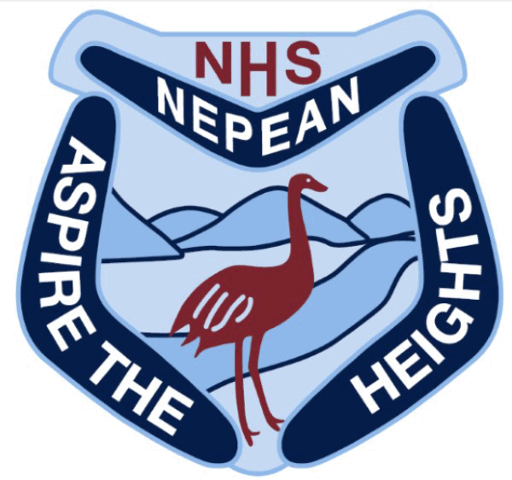
Nepean
Creative & Performing Arts
High School
Mr M Foord, Principal
115-119 Great Western Highway
Emu Plains, NSW, 2750
Locked Bag 6004, Emu Plains 2750
Phone: (02) 4728 7200
Fax: (02) 4735 6141
Email: nepean-h.school@det.nsw.edu.au
Website: www.nepeancapahigh.nsw.edu.au

ASSESSMENT TASK COVER SHEET

Faculty: Creative Arts
Course Name: Year 9 Advanced Visual Arts
Date Issued: Term 1 Week 8 2020
Due date: Term 3 Week 1 2020

Assessment Task Number: 1
Assessment Task Title: The Natural Environment Body of Work
Assessment Weighting: 30%
Total marks allocated to this task: 120 marks
Design a pair of shoes and construct into a handmade sculpture
- You will need to demonstrate research and development of your shoe design in your Visual Design Diary.
- You will be completing numerous class tasks in the development of your design work and these will be taken into account in your final mark.

Assessment Weighting: Part A Term 2 Week 2 30% Part B Term 1 week11 20%
Total Marks Allocated to this task: /100

Outcomes Assessed:
5.1 Develops range and autonomy in selecting and applying visual arts conventions and procedures to make artworks
5.2 Makes artworks informed by their understanding of the function of and relationships between artist – artwork – world – audience
5.3 Makes artworks informed by an understanding of how the frames affect meaning
5.4 Investigates the world as a source of ideas, concepts and subject matter in the visual arts
5.5 Makes informed choices to develop and extend concepts and different meanings in their artworks
5.6 Demonstrates developing technical accomplishment and refinement in making artworks

Task Description:
You are required to complete and submit a Body of Work on the Natural Environment. This must include the 6 artworks listed below:
There is a total of 6 Artworks for submission:
Artwork Number | Title | Mark Allocation
1 | Mixed Media Drawing | 20
2 | Collagraph | 20
3 | Cyanotype Print | 20
4 | Paper Landscape | 20
5 | Ceramic Sculpture | 20
Total Marks |  | 100

Things you need to KNOW to complete this task:

Content | Your answer will be assessed on how well you:  - Investigate artmaking using the Frames, Conceptual Framework and Practice  - Synthesise information in written and visual responses  - Demonstrate your visual literacy – using art language and analytical skills
Skills (verbs) | Researching, Reacting, Responding, Explaining, Describing, Interpreting, Investigating, Considering, Discussing, Analysing, Defining, Clarifying, Evaluating and Reflecting

Things you need to DO to complete this task:

Step | Things I will do | What I will see as a result
1 | Listen and engage in Visual Arts lessons ensuring that set activities are organised, completed, archived. | A series of works, which reflects my conceptual and material/technical advancements, knowledge and understanding in making artworks.
2 | Carefully read the assessment task instructions. Seek clarification with your teacher about any part of the task instructions you do not understand. | A thorough, accountable and organised Collection Of Work.
3 | Read class notes, view presentations and participate in class discussions. | Develop an understanding and appreciation for the representation of the skull as an enduring symbol in artworks
4 | Investigate subject matter and organise composition. Explore and experiment with chosen media and techniques, develop meaning in artworks. Submit work for critical feedback and advice. Apply feedback. | A Collection Of Work that demonstrates an understanding of Arts Practice, the Frames and The Conceptual Framework.

MARK SHEET
Artwork 1 | Mark | Rubric |  |  | A | B | C | D | E
Mixed Media  Artwork | /20 | 5.1 Overall judgement
 |  | 5.2 development of concepts
 |  | 5.3 Development of layers of meaning
 |  | 5.4 /5.5 Choices are informed and extended
 |  | 5.6 mastery of media
Artwork 2 | Mark | Rubric |  |  | A | B | C | D | E
Collagraph | /20 | 5.1 Overall judgement
 |  | 5.2 development of concepts
 |  | 5.3 Development of layers of meaning
 |  | 5.4 /5.5 Choices are informed and extended
 |  | 5.6 mastery of media
Artwork 3 | Mark | Rubric |  |  | A | B | C | D | E
Paper Landscape | /20 | 5.1 Overall judgement
 |  | 5.2 development of concepts
 |  | 5.3 Development of layers of meaning
 |  | 5.4 /5.5 Choices are informed and extended
 |  | 5.6 mastery of media
Artwork 4 | Mark | Rubric |  |  | A | B | C | D | E
Dry Point Etching | /20 | 5.1 Overall judgement
 |  | 5.2 development of concepts
 |  | 5.3 Development of layers of meaning
 |  | 5.4 /5.5 Choices are informed and extended
 |  | 5.6 mastery of media
Artwork 5 | Mark | Rubric |  |  | A | B | C | D | E
Solar Plate Etching | /20 | 5.1 Overall judgement
 |  | 5.2 development of concepts
 |  | 5.3 Development of layers of meaning
 |  | 5.4 /5.5 Choices are informed and extended
 |  | 5.6 mastery of media
Artwork 6 | Mark | Rubric |  |  | A | B | C | D | E
Personal Space Drawing | /20 | 5.1 Overall judgement
 |  | 5.2 development of concepts
 |  | 5.3 Development of layers of meaning
 |  | 5.4 /5.5 Choices are informed and extended
 |  | 5.6 mastery of media
TOTAL | /120
Grade A  Outstanding Achievement  90 - 100 | Grade B  High Achievement  80 - 89 |  | Grade C  Sound Achievement  60-79 | Grade D  Basic Achievement  30-59 | Grade E  Non attempt  <29

TOTAL MARK /100
Reflecting on Learning …

STUDENT REFLECTION (to be completed with submission)
(Circle a number: 1 = strongly agree to 5 = strongly disagree)

This is my best work | 1 | 2 | 3 | 4 | 5
I was organised | 1 | 2 | 3 | 4 | 5
I understood the task | 1 | 2 | 3 | 4 | 5
I took notice of the marking guidelines | 1 | 2 | 3 | 4 | 5
- What I have learnt most about the Assessment task: _________________________________
___________________________________________________________________________
- What I found most challenging about the Assessment Task was: _______________________
___________________________________________________________________________
- Next time I will: ______________________________________________________________
___________________________________________________________________________
- My strengths in the task were: ___________________________________________________
___________________________________________________________________________

STUDENT REFLECTION (To be completed when you return of the task)
AREAS FOR IMPROVEMENT | METHOD OF IMPROVEMENT
I would like to seek further clarification or assistance with:
- ________________________________________________________________________
- ________________________________________________________________________
- ________________________________________________________________________
Student Name: _________________________ Student Signature: _____________________
Parent Signature: _______________________ Date: _________________
Parent Comment (Optional): _________________________________________________________
________________________________________________________________________________

Assessment Marking Guidelines: Critical Review
Performance Descriptors | Marks
- Demonstrates a sophisticated range and autonomy in selecting and applying visual arts conventions and procedures to make artworks  - Demonstrates a sophisticated investigation of the world as a source of ideas, concepts and subject matter in the visual arts  - Demonstrates sophistication in informed choices to develop and extend concepts and different meanings in their artworks  - Demonstrates sophisticated development of technical accomplishment and refinement in making artworks | 90-100
- Demonstrates a well-developed range and autonomy in selecting and applying visual arts conventions and procedures to make artworks  - Demonstrates a well-developed investigation of the world as a source of ideas, concepts and subject matter in the visual arts  - Demonstrates well-developed informed choices to develop and extend concepts and different meanings in their artworks  - Demonstrates well-developed development of technical accomplishment and refinement in making artworks | 80-89
- Demonstrates a sound range and autonomy in selecting and applying visual arts conventions and procedures to make artworks  - Demonstrates a sound investigation of the world as a source of ideas, concepts and subject matter in the visual arts  - Demonstrates sound choices to develop and extend concepts and different meanings in their artworks  - Demonstrates sound development of technical accomplishment and refinement in making artworks | 60-70
- Demonstrates a limited range and autonomy in selecting and applying visual arts conventions and procedures to make artworks  - Demonstrates a limited investigation of the world as a source of ideas, concepts and subject matter in the visual arts  - Demonstrates limited choices to develop and extend concepts and different meanings in their artworks  - Demonstrates a limited development of technical accomplishment and refinement in making artworks | 30-59
- Demonstrates a basic range and autonomy in selecting and applying visual arts conventions and procedures to make artworks  - Demonstrates a basic investigation of the world as a source of ideas, concepts and subject matter in the visual arts  - Demonstrates basic choices to develop and extend concepts and different meanings in their artworks  - Demonstrates a basic development of technical accomplishment and refinement in making artworks | <29
- No attempt is made | 0

